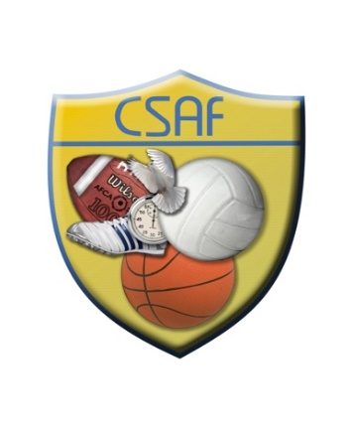

CSAF District QUALIFIER GOLF TOURNAMENT
April 4, 2019

Oak Hollow Country Club
3005 N McDonald St, McKinney, TX 75071
Tournament participants must observe dress code and all prevailing rules and regulations covering the use of the course and clubhouse. Soft spikes are mandatory. Dress code includes collared shirt for men, appropriate golf shift for ladies and tailored shorts or pants. A 2.5 hour pace of play is strictly enforced.
Please list golfers below in order from player with lowest average score to highest. You may use multiple forms if necessary. Please use separate forms for boys and girls. Tournament entries will be cut off at 70 participants.
Registrations will close March 31st at 6:00pm.
No registrations will be accepted after this date. No walk ups will be received.
8:00am Shotgun Start (Sign in starts at 7:00 am)
$25 per player ( will include lunch)
(Checks made payable to Westlake Academy Athletics)
(2600 JT Ottinger Rd. Westlake, TX 76262)
School_______________________ Coach________________________

Player 1.
Player 2.
Player 3.
Player 4.

Email forms to cnothe@westlakeacademy.org no later than March 31th

